**Expt 5 - C++ decision making statements**

**NAME: Saanvi Mohapatra**

**PRN:23070123110**

**BRANCH: EnTC-B2**

**Aim:** To study and implement C++ decision making statements

Simple if-else:

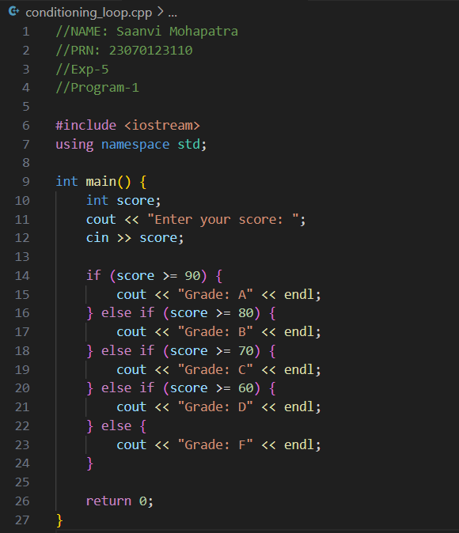

Output:

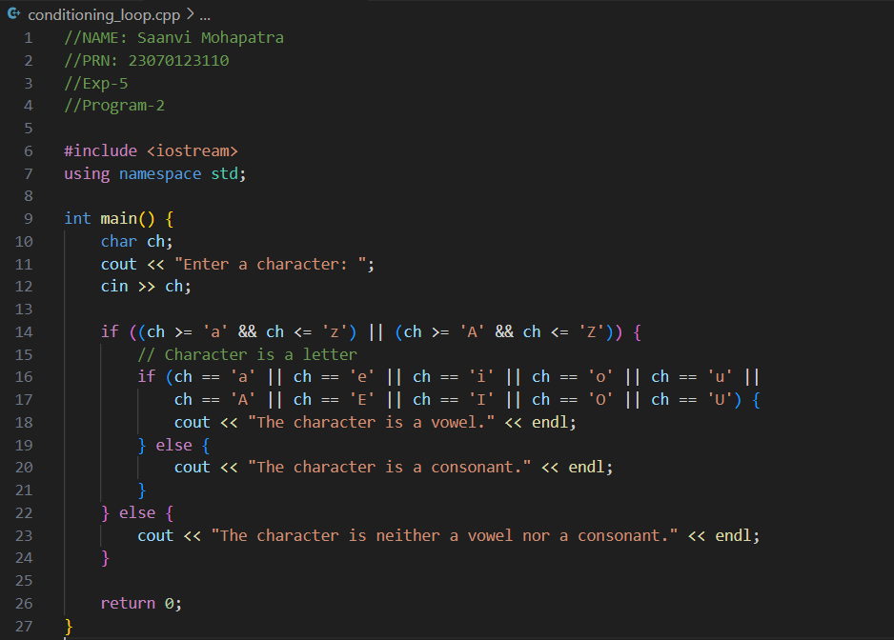Nested if-else:

Output:



The break Keyword:

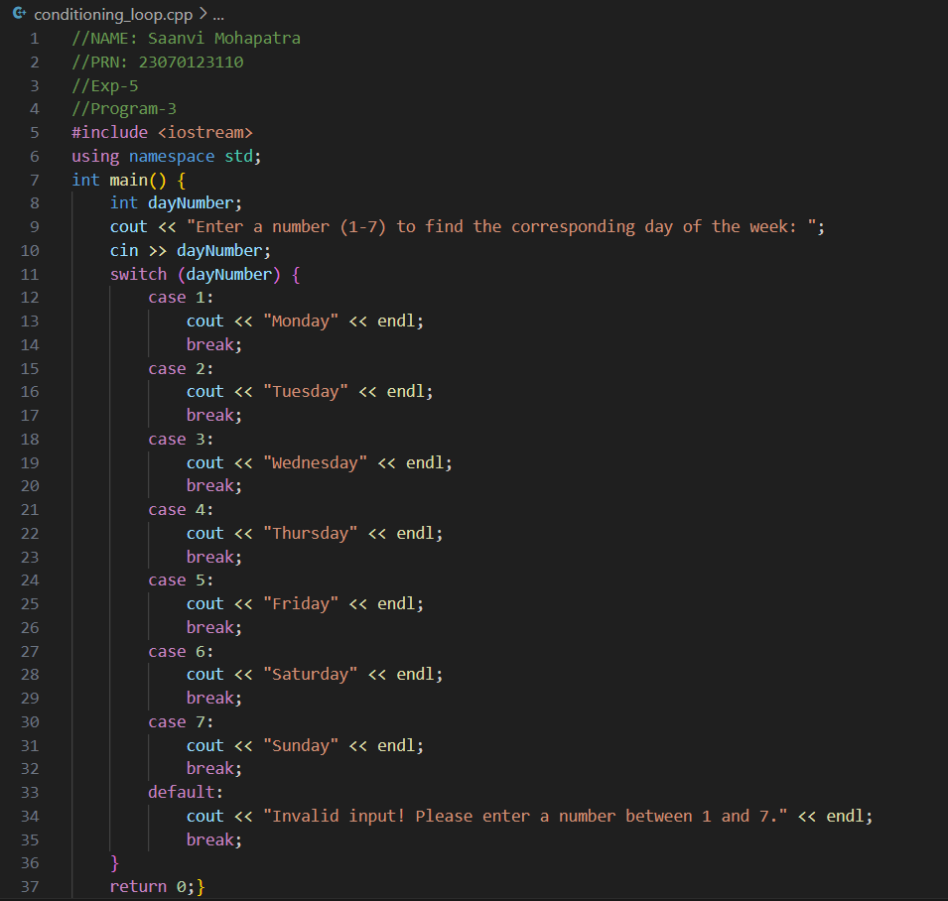

Output:

Calculator Code:

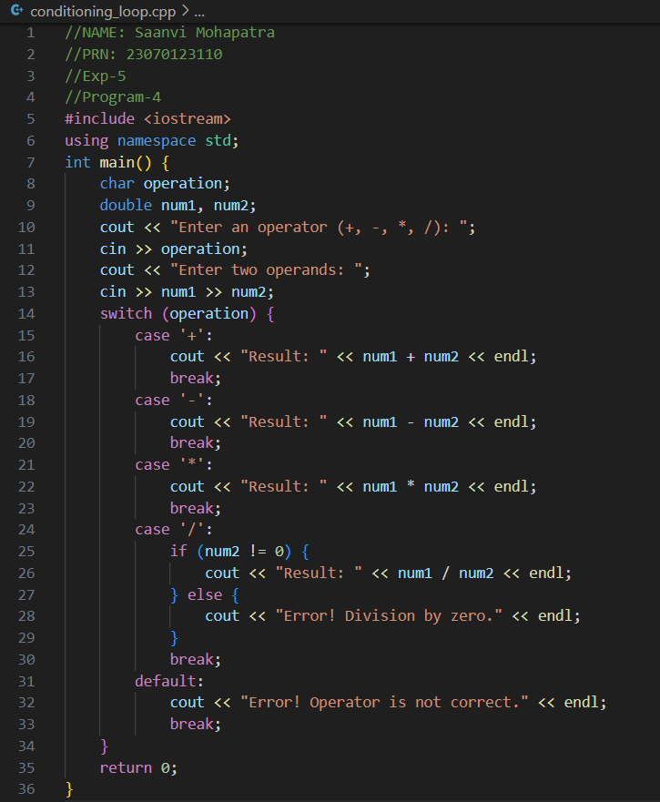Output:

